Practice Problems

1.

f(2)=3 , f(4)=5, f(5)=8

Prepare an overdetermined system and then solve using

1. Least Square Method
2. QR Decomposition

2.

f(18)=22 , f(19)=35, f(20)=60

Prepare an overdetermined system and then solve using

1. Least Square Method
2. QR Decomposition

3.

f(18)=22 , f(19)=35, f(20)=60, f(25)=80

Prepare an overdetermined system using quadratic Polynomial and then solve using

1. Least Square Method
2. QR Decomposition

4

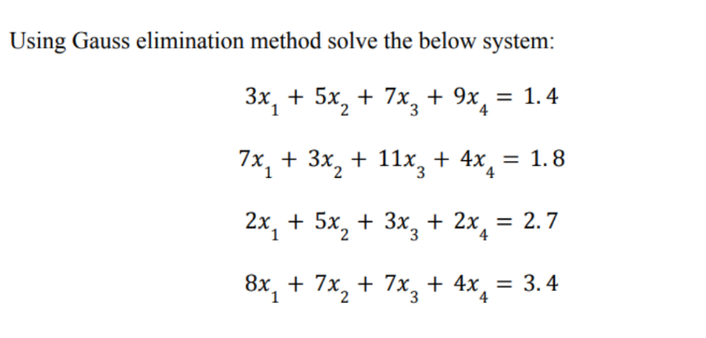

Solve using LU Decomposition as well

5 

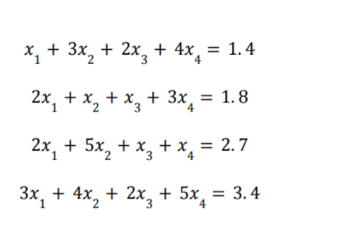

Solve using LU Decomposition as well

6

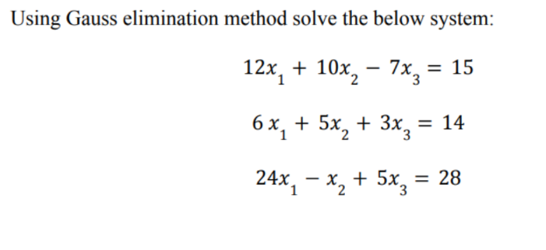

Solve using LU Decomposition as well

7

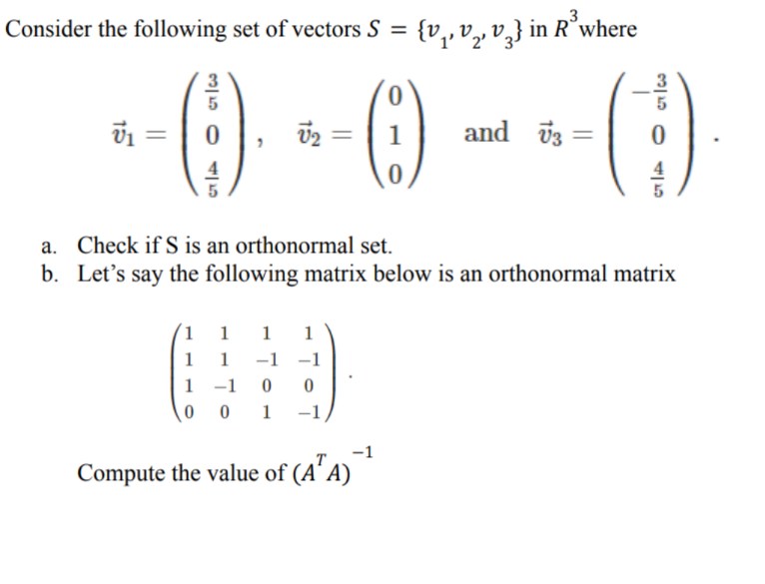

8

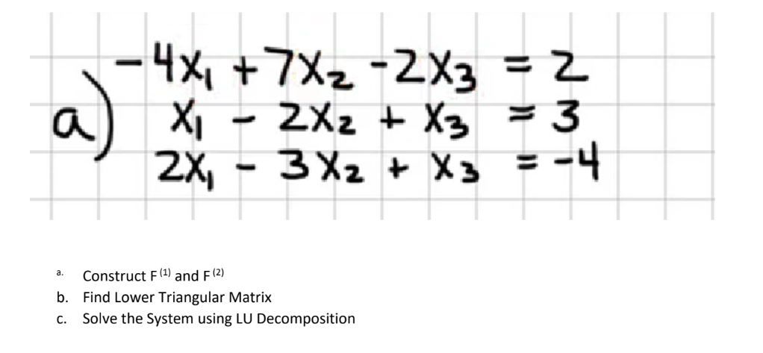

9

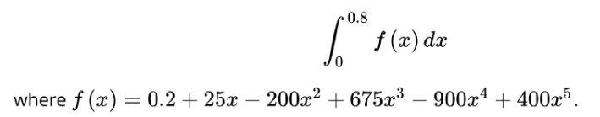





10



